USER GUIDE TB-9112

Common Point Ground Monitor
Installation, Operation and Maintenance Made in the
United States of America
Use the Common Point Ground Monitor to fulfill the ANSI/ESD S6.1 section 6.3.1 requirement. “The hot, neutral and equipment grounding conductor shall
be verified to be in the proper wiring orientation in accordance with the National Electric Code (NFPA 70®).”
The Common Point Ground Monitor is available as the following item numbers:

Item | Description
770048 | Common Point Ground Monitor, with North America Power Cord
770049 | Common Point Ground Monitor, with UK Power Cord

Figure 1. SCS Common Point Ground Monitor

Description
The SCS Common Point Ground Monitor confirms the integrity of the resistance path from the common ground point to electrical ground. It is designed in accordance with ESD TR 12-01 to “monitoring equipment ground connections.”
When the Common Point Ground Monitor is plugged into an electrical receptacle, its green LEDs illuminate when both the power outlet's wiring is correct and
the path-to-equipment ground via the equipment grounding conductor is intact. The monitor provides 12 verified ground points when in a PASS condition.
The monitor's red LEDs illuminate and audible buzzer sounds when either the outlet’s wiring is incorrect or the path-to-equipment ground is defective. Mounting tabs make it suitable to install in workbench or equipment settings.
The outlet ground line is tested by measuring voltage between it and the neutral line. It is normal to have
a few volts of AC induced on the neutral line. If the Common Point Ground Monitor measures only a few volts, the ground line to neutral impedance is low and the ground line would make a suitable ESD ground point. If the monitor measures more than just a few volts between ground and neutral, this indicates either that they are not referenced to each other or that the outlet and associated wiring should be checked for loose connections. In this case, the Common Point Ground Monitor will sound a warning alarm and display a red FAIL indication and should not be used for an ESD grounding point until corrected.

Packaging
1 Common Point Ground Monitor
6 Socket Head Screws, 10-32 x 1/4"
6 Split Washers, #10
2 Pan-Head Screws, #6 x 3/8"
1 Dual Lock Fastener Set, 2" Length
1 Hex Key, 5/32"
1 Power Cord, 6' Length
1 Certificate of Calibration




TEXAS TECHNOLOGIES INC.
www.texastechnologies.com – E-mail – info@texastechnologies.com 800.858.1379

Features and Components Installation
- Remove the Common Point Ground Monitor and its power cord from their carton.
- Determine the mounting location of the Common Point Ground Monitor. Its LEDs should be visible to the operator. Secure the Common Point Ground
Monitor to a surface using its mounting tabs and the included pan head screws or dual lock fasteners.
- Connect the power cord to the power inlet located on the right-side of the Common Point Ground Monitor. Connect the opposite end to an appropriate AC outlet.
- The status LEDs will illuminate green if the AC outlet is wired correctly and its path-to-equipment ground via the equipment grounding conductor is intact. The status LEDs will illuminate red, and the audible buzzer will sound otherwise.

Figure 2. Common Point Ground Monitor features and components
- Status LEDs: Illuminates green when the AC outlet is properly wired and its path to equipment ground via the equipment ground conductor is intact. Illuminates red and audible alarm sounds when the AC outlet is not properly wired and its path to equipment ground via the equipment ground conductor is broken.
- Ground Hub: Brass machined hex block with six banana jacks and six screws for #8 ring terminals. Provides grounding point for wrist straps, ground cords, and tools.
- Power Inlet: Connect the included power cord here.
Figure 3. Installing the Common Point Ground Monitor at the end of a row of workbenches

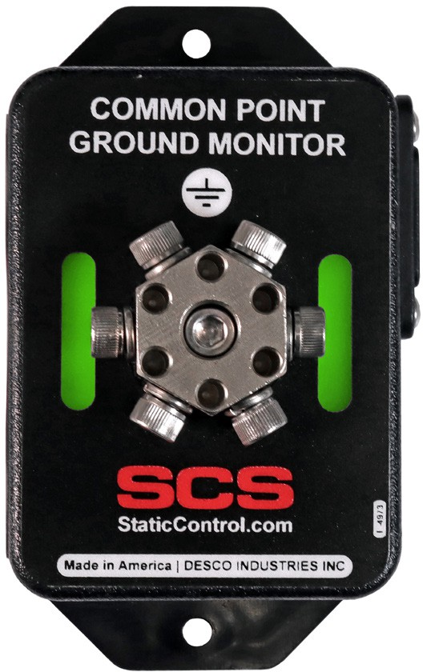
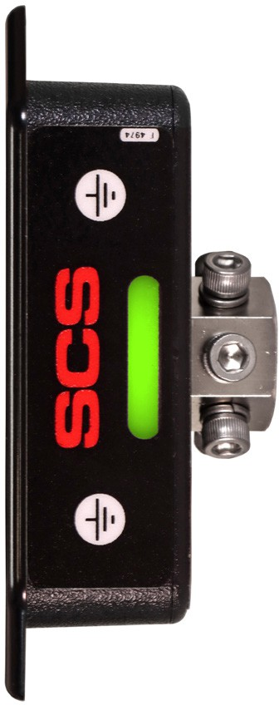
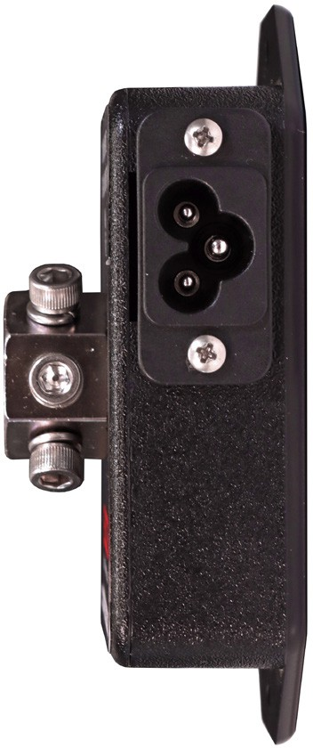

A
B
A
C
A

TEXAS TECHNOLOGIES INC.
www.texastechnologies.com – E-mail – info@texastechnologies.com 800.858.1379

Operation
Use the banana jacks on the ground hub to connect banana plugs to ground. Use the 6 included socket head screws and split washers to secure ground wires with ring terminals.

Figure 4. Using the Common Point Ground Monitor

Calibration
Frequency of recalibration should be based on the critical nature of those ESD sensitive items handled and the risk of failure for the ESD protective equipment and materials. In general, SCS recommends that calibration be performed annually.
NOTE: The following procedure should only be done by someone familiar with voltage hazards. This procedure will work for 220 VAC as long as the neutral and ground are referenced. 220 VAC produced with out-of-phase 110VAC-Ground-110VAC will produce a FAIL result.
- Disconnect the power cord from the electrical outlet and connect it to a 3-prong to 2-prong adapter to isolate its ground pin.
- Connect the 3-prong to 2-prong adapter to an appropriate AC outlet to power the Common Point Ground Monitor.
- Connect a 5 kilohm resistor (5% tolerance) between the supply ground and power cord's ground pin. The status LEDs should illuminate green until the resistor is removed. This test validates the PASS point for the neutral-to-ground resistance.
- Connect a 12.5 kilohm resistor (5% tolerance) between the supply ground and power cord's ground pin. The status LEDs should illuminate red and audible buzzer should sound. This test validates the FAIL point for the neutral-to-ground resistance.

Specifications

Input Voltage and Frequency | Power Input:  100-240 VAC, 50/60 Hz  Power Cord Length: 6 ft. (1.8 m)
Operating Temperature | 50 to 95° F (10 to 35° C)
Environmental Requirements | Indoor use only at altitudes less than 6500 ft. (2 km)  Maximum relative humidity of 80% up to 85° F (30° C)  decreasing linearly to 50% @ 85° F (30° C)
Dimensions | 4.38" L x 2.47" W x 1.00" H  (111 mm x 63 mm x 25 mm)
Weight | 0.35 lbs. (0.16 kg)
Equipment Ground Conductor Resistance Limit | 10 kilohms (nominal)
Country of Origin | United States of America

Limited Warranty, Warranty Exclusions, Limit of Liability and RMA Request Instructions
See the SCS Warranty - StaticControl.com/Limited-Warranty.aspx

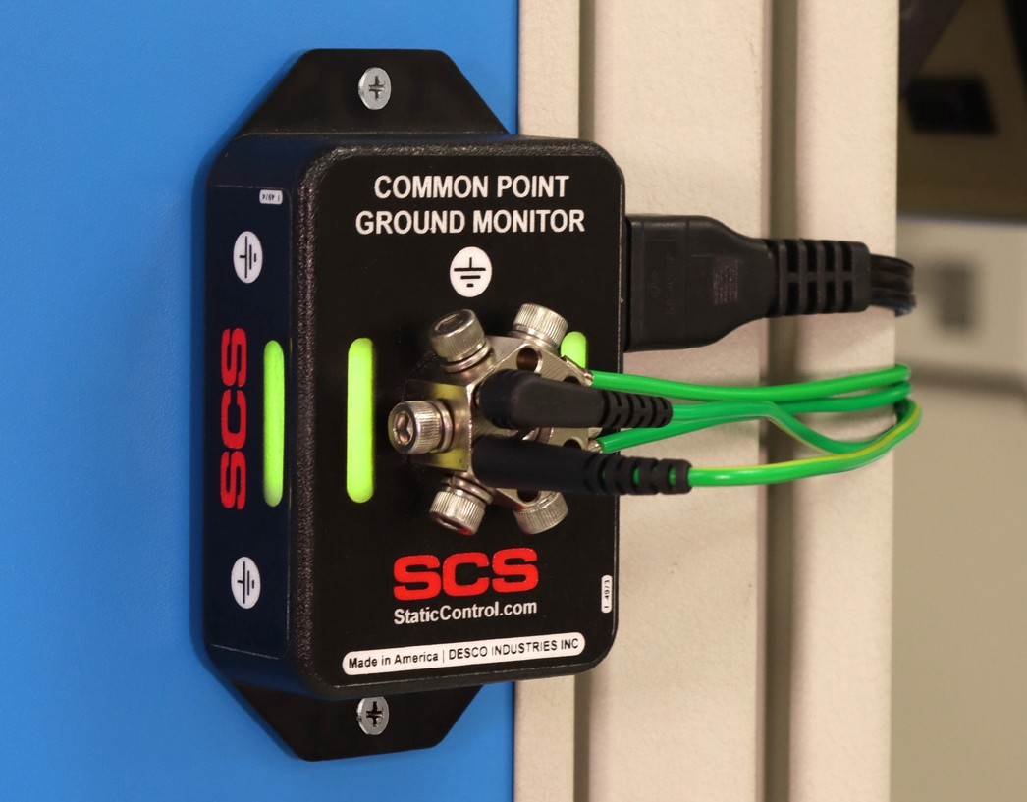

TEXAS TECHNOLOGIES INC.
www.texastechnologies.com – E-mail – info@texastechnologies.com 800.858.1379

